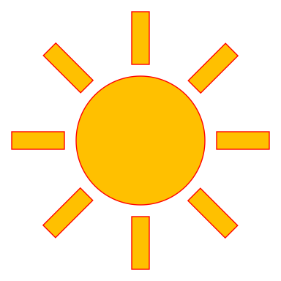

March 23, 2020 Newsletter
Dear Parents and Guardians,
We are continuing to work on the unit this month called Light. In this unit the children will be able to explore light in all its forms, in their environment as well as outer space. Due to COVID-19 health crisis formal classes are not being held. In lieu we will be sending home weekly packets and updates to address the educational needs of our students.

Vocabulary: Batteries, Clouds, dark, day, diurnal, eyes, eyesight, grow, heat, horizontal, melt, mirror, night, nocturnal, opaque, power, reflection, see, shade, sight, solar, spiral, sunglasses, transparent, translucent, vertical, zigzag, candle, curve, electricity, fire, flame, flashlight, horizontal, lamp, lantern, light, light bulb, lightening, lines, moon, parallel, rainbow, spiral, stars, straight, sun, traffic light, vertical, zigzag, parallel, shadow, silhouette, outline, weather, wavy.

Special Parent Activity: We are asking parents to work on our class activity of growing plants in both light and dark. The exercise is explained in the lesson and to also graph the progress of the growth of the plants from beans on a simple graph, looking at the progress daily.
Another activity could be to chart the sunrise and sunset times daily, as the spring equinox happened on Friday and days are getting longer.
I am also including the texts we are reading, and they can be found on YouTube, NYPL.org, or archive.org (a free online lending library). This resource is free and only requires parents to sign up. I am attaching our daily schedule with suggestions for activities.

I am also attaching the CDC guidelines for dealing with the Covid19 crisis and this can be used to have a conversation with your child about the changes in their school attendance.

We are all in this together and will work towards helping your child continue their learning activities.

